Ashes of Kanaka: The Open World JRPG Breaking the Boundaries of RPGMaker.
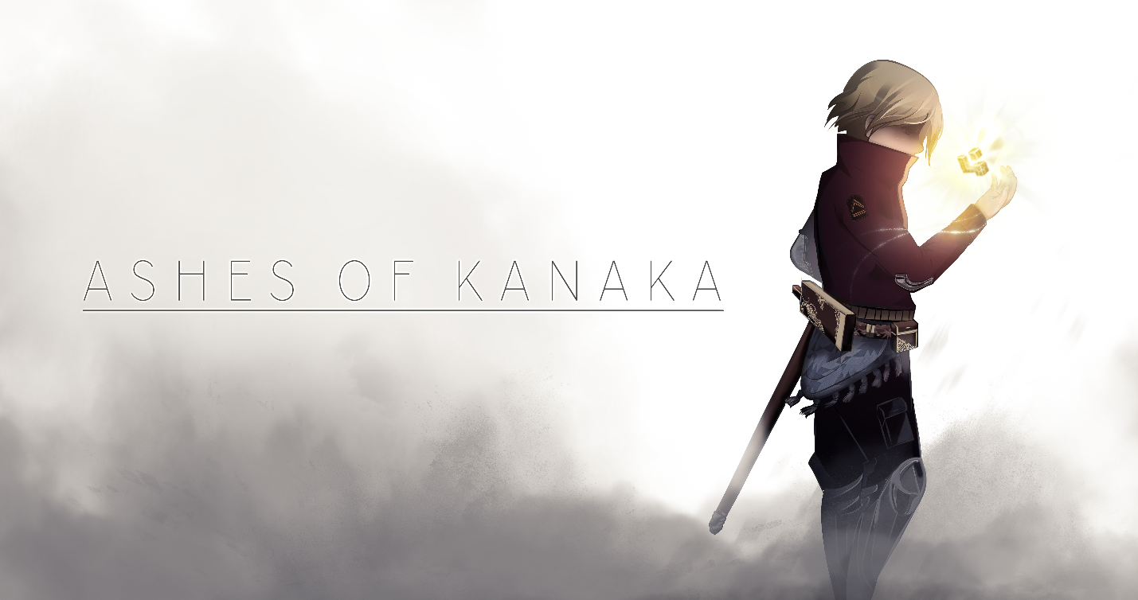
Ashes of Kanaka is a story of humanity’s struggle to survive. After Earth has been completely destroyed by over harvesting and an unchecked population growth, we must look to the stars to find a new home. Our story begins several years after our first arrival on Kanaka, civilization has grown and cities and towns can be found on every corner. You awake in intensive care, under the watchful gaze of the Order of the All Seeing Eye, an organization dedicated to keeping humanity safe and strong no matter who may oppose them. You must protect humanity from CODE, a technology advanced civilization of androids, and TERRA, an ancient civilization that claims to have reached the echelon of godhood. As you begin your first investigation, you become aware of a greater galactic tournament where ownership of the planet is transferred to the winner. Humanity needs this victory, but it becomes apparent that whatever is actually on the planet, is worth entire species to give their lives for.
- Ashes of Kanaka is made in a completely modded version of RPGMaker with custom coding and formulas made in house to push the engine to its limits.
- 60-100 hours of gameplay, breaking all records of length for an RPGMaker game.
- 54 hand created companions to join you on your adventure. Every companion will tweak how the story is presented, allowing for over six million different playthroughs.
- An expansive world that covers most every biome in existence. From the snowy fields of Norda Morlone to the dark jungles of Kushmala, to the vast deserts of Hayphon. Every region is unique and fully fleshed out.
- A comprehensive story that allows player choice, the player will decide the fate of not just individual actions, but as well the over-arching plot will be decided by how the player chooses to play.
- Dozens of fully fleshed out side missions that take place across the entire world, filled with a story in their own right that develops the world around the player.
- Fifteen different classes, each with three different weapon types for each. Along with the base weapons, the player will find legendary weapons for themselves and their party, which grow and can be customized to the player’s playstyle.
- A fully custom musical score done by producers from The A-Team, who have worked with big names such as Nas and Future.
Made by a team of fourteen dedicated video game fans who wanted to bring their passion to the industry. An effort of a year and a half round the clock dedication toward building a world for JRPG and traditional RPG fans alike.

